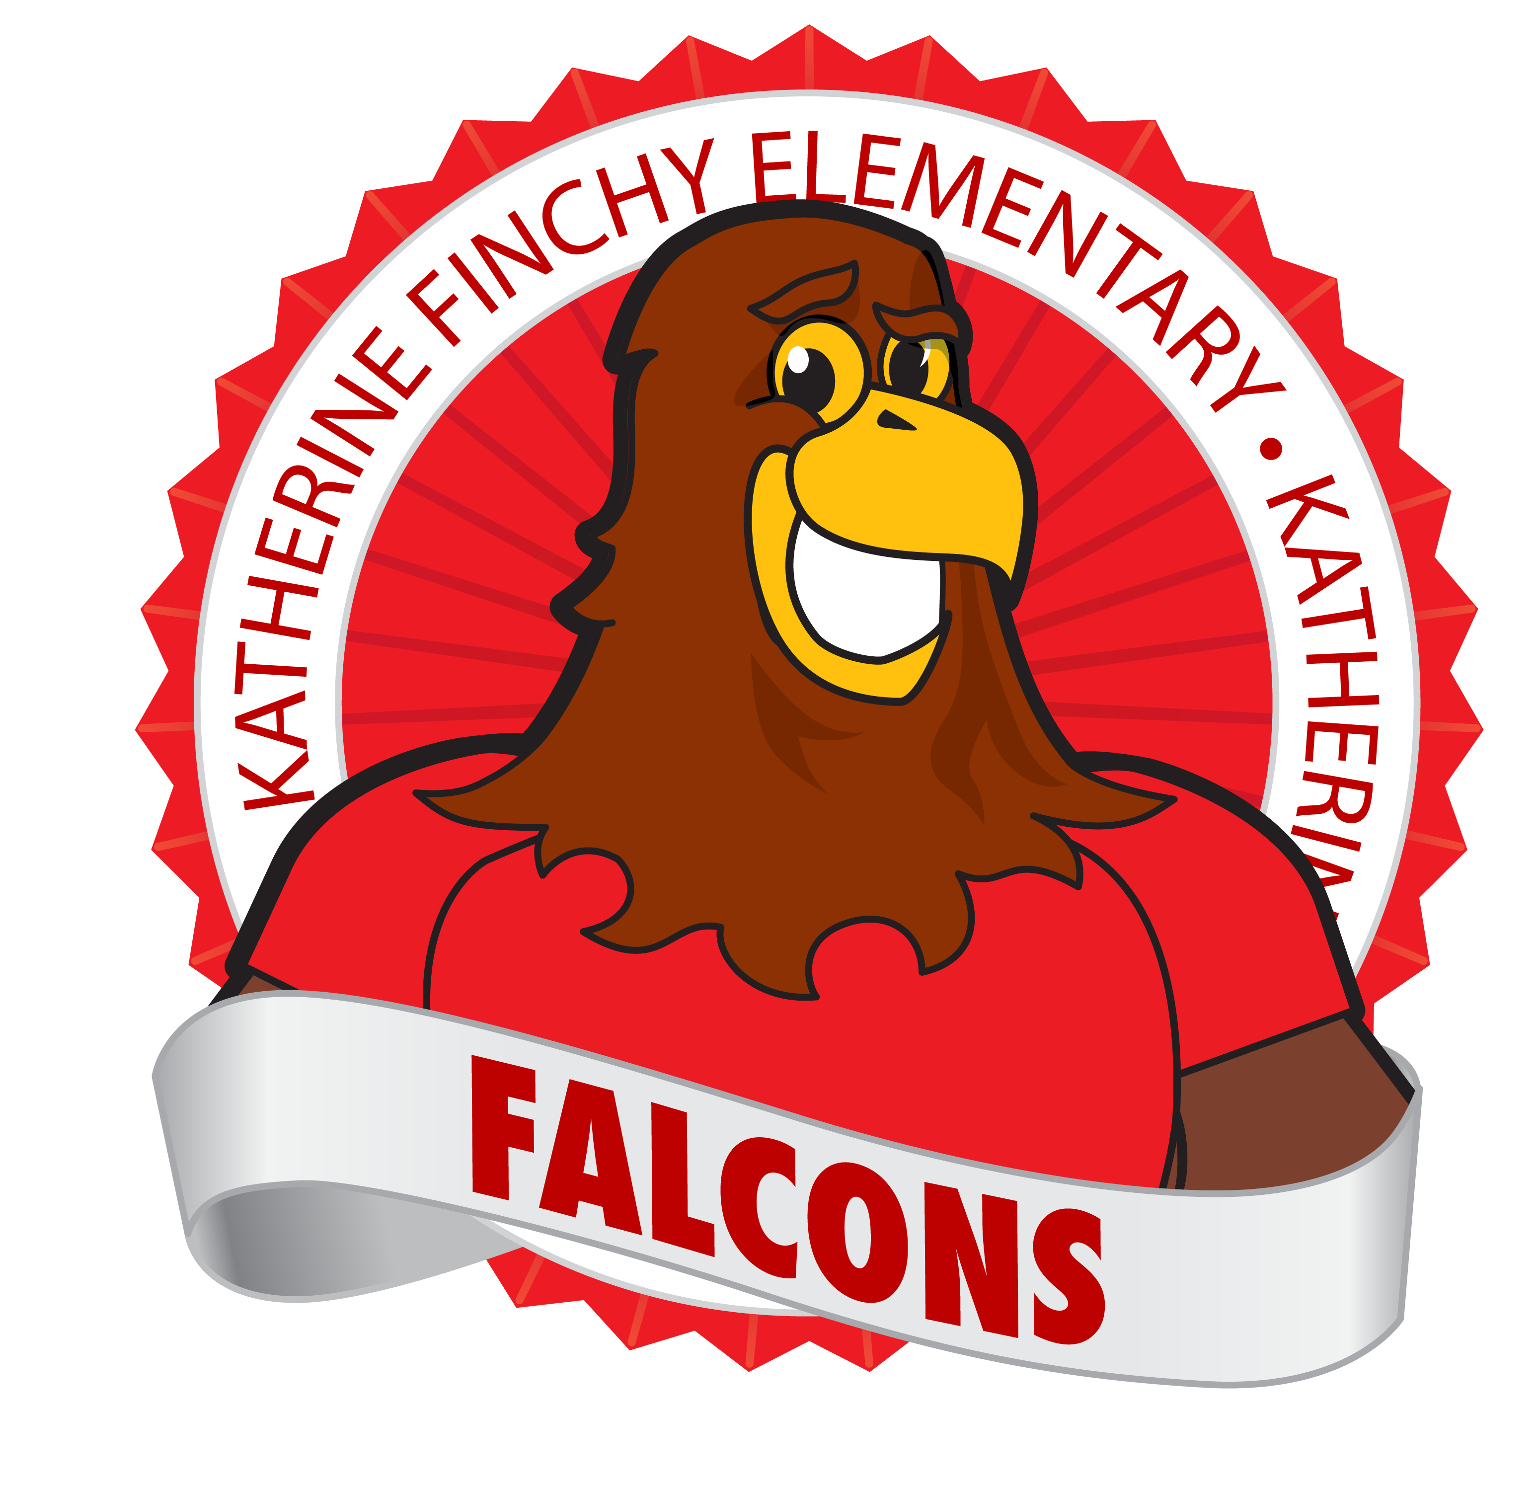
Palm Springs Unified School District
Dr. Sandra Lyon, Superintendent

Parent/ Student Handbook
2020-2021
Katherine Finchy Elementary School
777 Tachevah Drive Palm Springs, CA 92262
(760) 416-8190 FAX (760) 416-8201
Office Hours: 7:30 a.m. – 4:00 p.m.
Mr. Matthew Hammond, Principal

Katherine Finchy Elementary School is an educational environment where individual differences and the rights of others are respected. We believe that every child will succeed with the help of his/her parents and teachers to his/her maximum potential in a safe and orderly academic environment.

Dear Parents/Guardians and Students,

On behalf of the teachers and staff, I would like to welcome you to Katherine Finchy Elementary School! We are looking forward to an exciting school year! Please review this handbook and discuss the importance of its contents with your child. You will find many answers to your questions within the pages of this handbook. Please encourage your child to comply with our rules and expectations. These rules are important in securing your child’s safety and academic progress. Please read through this handbook carefully for information regarding acceptable dress.
We encourage you to visit the school and take an active part in your child’s education. Throughout the year, you will have many opportunities to be involved in school activities. We welcome and encourage your help and support. We are a closed campus; however, so you will need to follow all safety protocols in place when coming to campus. We use a system called Raptor to help promote a safe environment when receiving visitors. We believe working together will provide a positive educational experience for your child.
The faculty and staff at Katherine Finchy Elementary constantly strive to provide the best education for your child. We are pleased to announce that every student at Katherine Finchy Elementary is provided with a free breakfast and lunch. We are very excited to begin the new school year and we have many fun and educational activities planned.
Our mission is to prepare our students for the future. We encourage students to set goals for college and their future career. We want the best for all of our students and we believe that every student can and will succeed.
My door is always open to you and I am happy to meet with you. If you would like to meet with me, please contact Mrs. Novy in the front office and she will schedule an appointment. Please let me know if you have any suggestions, concerns, or you would like to forward a compliment to any of our staff. Working as partners together, we can make a difference in your child’s academic journey.

Sincerely,
Matthew Hammond- Principal
mhammond@psusd.us
760-416-8161

School Bell Schedule

TK (transitional kindergarten)
8:40 a.m. – 12:15 p.m.

Grades K-5 Monday, Tuesday, Thursday, Friday
School begins at 8:40 a.m. Students need to be in line ready for school to begin.
School ends at 3:30 p.m. Students will exit through the front gates and side gates.

Grades 1-5 Every Wednesday
School begins at 8:40 Students need to be in line ready for school to begin.
School ends at 1:05 Students will exit through the front gates.

STARS Pre School Autism Program
School begins at 8:40 Families dropping children off will do so by the bus line
School ends at 1:58 Families picking up children will do so by the bus line

General Information
Attendance
Good attendance and promptness is vital to learning. Please help your child understand the importance of attending school and getting to school on time. Students coming in to class late, or leaving early, miss out on important instruction and cause unnecessary distractions for the other students in the classroom. Making every effort to have your child in school on time, every day, all day is one of the greatest contributions a parent can make to their child’s education.

***Perfect Attendance is defined as being in school all day, every day.
Notification of Absence
All absences are to be reported to the school on the same day as the absence. The school office is open from 7:30 a.m. to 4:00 p.m. to receive phone calls. The school telephone number is 416-8190. If the absence is not verified by telephone, a written reason is required upon the student’s return to school. The note should state the child’s first and last name, the day of the absence, the reason for the absence, and parent signature.

Absences
School attendance is compulsory in California. Children are excused from attending school only for illness, medical or dental appointments, a court appearance (for the child), or death in the family. Excuses such as missing the bus, visiting with friends, or personal reasons are unexcused by the State and are considered instances of truancy.

EXCUSED ABSENCES:
(a) Notwithstanding Section 48200, a pupil shall be excused from school when the absence is:
(1) Due to his or her illness.
(2) Due to quarantine under the direction of a county or city health officer.
(3) For the purpose of having medical, dental, optometric, or chiropractic services rendered.
(4) For the purpose of attending the funeral services of a member of his or her immediate family, so long as the absence is not more than one day if the service is conducted in California and not more than three days if the service is conducted outside California.
(5) For the purpose of jury duty in the manner provided for by law.
(6) Due to the illness or medical appointment during school hours of a child of whom the pupil is the custodial parent.
(7) For justifiable personal reasons, including, but not limited to, an appearance in court, attendance at a funeral service, observance of a holiday or ceremony of his or her religion, attendance at religious retreats, attendance at an employment conference, or attendance at an educational conference on the legislative or judicial process offered by a nonprofit organization when the pupil's absence is requested in writing by the parent or guardian and approved by the principal or a designated representative pursuant to uniform standards established by the governing board.
(8) For the purpose of serving as a member of a precinct board for an election pursuant to Section 12302 of the Elections Code.
(9) For the purpose of spending time with a member of the pupil's immediate family, who is an active duty member of the uniformed services, as defined in EC § 49701, and has been called to duty for, is on leave from, or has immediately returned from, deployment to a combat zone or combat support position. Absences granted pursuant to this paragraph shall be granted for a period of time to be determined at the discretion of the superintendent of the school district.

Independent Study
Independent study is approved by the principal for important absences lasting more than 5 days. First, meet with the principal for approval at least 5 days before the first day of independent study. After approval and completing the independent study form the office will request a study packet from the teacher. The teacher will need two days to prepare the packet. After the packet is prepared it will be available in the office for pick-up. When it is completed return it to the school office.

Arrival at School
Students should not arrive at school before supervision begins. Supervision begins at 8:25 a.m.

Tardies
School begins promptly at 8:40 a.m. Parents are responsible for getting children to school on time. When a student is tardy he/she disturbs the rest of the class and misses part of the instructional program. Students who arrive after 8:40 a.m. must report to the office to obtain a permit to enter class.

Excessive tardies can result in a referral to School Attendance Review Team (SART), or the School Attendance and Review Board (SARB). Tardies count against perfect attendance. Arriving more than thirty minutes late and unexcused is a truancy.

Tardies for a doctor appointment can be excused by bringing a note from the doctor’s office.

Leaving Campus During School Hours
Katherine Finchy Elementary is a closed campus. Once students arrive, they may not leave the campus until dismissal except for a legally excused reason. Parents are urged to make every effort to schedule doctor or dental appointments during non-school hours. When early dismissal is necessary, a parent or guardian must come into the office before 3:15 to sign out a student. Students will be called from class only after being signed out. 3:15-3:30 is a hectic time in the classroom; students can’t be called out during that time. The person escorting the student from school grounds must be on the Emergency Card and must show valid identification.

Beginning of the School Day
Student safety is important before school. Students are allowed in the cafeteria if they are having breakfast at 8:10 and all students will be allowed on campus at 8:25. There is no supervision in the front of the school before 8:00 AM. Drop off students or send them to school so that they arrive at or after 8:10 for breakfast or 8:25 if they have breakfast at home. It is unsafe to leave or send your child before these times. Instruction starts at 8:40.

Parent on campus before school
The cafeteria is limited to students and staff during this period. If you prefer, your can have your child arrive right before 8:40 and proceed directly to the classroom. Parents’ complete cooperation is important at this time. The minutes used by supervision staff to interact with parents on campus, takes important time away from supervising children.

End of the School Day
Students are supervised in the pick-up area for 15 minutes after the dismissal bell. Please do not ask your child to go to the park or any other area for pick-up. All supervision is on the grassy pick up area on the northeast side of the school. Please arrange to pick-up your child at 3:30 dismissal.

All students being picked up by car will be loaded curb side in the pick-up area. Day care vans will wait and pick-up in the kindergarten pick up area. Students in day care vans will be escorted by drivers. No other student will be allowed to walk in or through the parking lot. It is not safe to have students attended or unattended walking through the parking lot to load in cars. Students who are walking or being picked up away from school property must exit the school using the sidewalks. Students riding the school bus will walk to the bus loading zone.

When picking up a child, by car, remember to:
- Arrive at school eastbound on Tachevah.
- Begin the car cue at the parking lot entrance and proceed through the loading area directly in front of the office. Please no double parking.
- Follow the direction of the staff to pull forward or wait for loading.
- Remember it is Right Turn only when exiting the parking lot.

Telephone Calls
The Katherine Finchy telephone number is 416-8190. Calls to the office will be answered from 7:30 A.M. until 4:00 P.M. Students will not be called out of class for phone calls unless it is an emergency. We understand that there may be a time when you must get a message to your child during the school day. To avoid classroom interruptions messages will be sent by email in the AM and by student courier in the PM.

Please write a note to the teacher if there is going to be a change in the procedure for how your child gets home.
The school phone is for school business purposes. Students may not use the phone except in an emergency. Please speak to your child and make arrangements with you before school about staying after school, visits to friends, etc.

Breakfast and Lunch
Breakfast is served daily in our cafeteria from 8:10 - 8:40 a.m. Breakfast is FREE, Lunch is served daily and is also Free.

Student Wellness
The food served in the cafeteria at breakfast and lunch meet nutritional guidelines. A variety of fruits and vegetables are available in the salad bar. This policy strongly encourages parents not to bring fast food lunches to school.

According to the Student Wellness Policy celebrations with food during school hours is very limited. The school allows interested teachers to have one 30 minute “nutritious snack” party per month. These can be at the end of the day on the last Friday of each month to celebrate the birthdays during that month or similar celebrations.

The wellness policy allows the following “sweet treat” parties:
Halloween
Christmas
Valentine’s Day
Easter
End of the school year

Please plan birthday celebrations away from school instructional time. The office and teachers will no longer accept treats and other arrangements for birthday parties. The school will provide a list of nutritious snack ideas for rooms that have an end of month party. We need to maximize the time we provide instruction to every student. Stopping instruction of all students for an individual’s birthday party reduces instructional time and makes party attendance a mandatory experience for the entire class.

For copies of the nutrient analyses of school lunches, please refer to the school menu. For a copy of the Student Wellness Board Policy in its entirety, please contact the school office or district office.

Cell Phones, Electronic Devices and Toys
Electronic devices and toys are not permitted at school. iPods, cd players, cell phones, and electronic games such as Game Boys are not allowed. Such items can be confiscated and will remain in the school office until picked up and signed out by parents. Basketballs, tetherballs, playground balls and soccer balls are provided for playground use. Soccer balls, basketballs and soft playground balls can be brought from home, but must be shared. No footballs or hard balls are allowed.

Textbooks and technology
Students are responsible for all books checked out to them. They are expected to take care of them and return them at the end of the year. If a textbook, technology or other school property is lost, stolen, or destroyed, it must be paid for. A bill will be sent to parents for any lost, damaged or destroyed item.

Parental Rights Regarding Custody Issues
By law, if parents are legally separated or divorced, each parent has equal rights to the custody of the child/children UNLESS a parent has a court order that indicates which parent has custody of the child/children. The school MUST HAVE A COPY OF THE COURT ORDER on file, otherwise, either parent may check the child out with proper identification.

School Uniform Policy

The Palm Springs Unified School District recognized in Board Policy that, “There is a generally held belief by educators that school dress significantly influences pupil behavior,” and “Schools that have adopted school uniforms have experienced a sense of pride, ‘ coming together feeling’ and better behavior in and out of the classroom.”
Rationale
At Katherine Finchy we continue to strive to build and enhance a positive school environment and community. Consistent meeting of the School Uniform Policy will enhance the school community. We will continue to work to praise and recognize students for meeting the uniform expectations. Our goal as a school has been to positively reward students meeting expectations to encourage adherence to this policy. Parent and student support of this school wide expectation would be greatly appreciated.
The adoption of a school uniform policy reaffirms the concept that students should be properly prepared for participation in the education process. School uniforms in a public school setting have been shown to enhance school safety, promote good behavior, and improve the learning environment. Uniforms at Katherine Finchy will support the academic focus, positively influence student behavior and provide the students with a safe and healthy environment.

Shirts and Blouses
Red, White or Navy Blue with collar
No t-shirts, unless they are Finchy Falcon Shirts
Slacks/Shorts/Skorts/Dresses/Jumpers
Khaki or Navy Blue Pants
All shorts and skirts need to be an appropriate length
Sweater/Jackets/Sweatshirts
Red, White or Navy Blue with no lettering
Red Finchy Falcon Sweatshirts
Shoes
Closed toes shoes must be worn at all times
White or black tennis shoes are recommended
No sandals, backless shoes or flip-flops are allowed
Shoes must be worn on campus at all times (BP 5132a)

If you cannot afford uniforms for your children, please contact the office. We will do everything we can to provide your children with the uniforms.

Clothing not acceptable at any time:

- Short shorts, bathing suits, bare midriffs or revealing tops
- No spaghetti strap dresses or blouses allowed
- No midriff showing allowed
- Clothing with obscene or offensive logos, graphics or lettering
- Clothing advertising or promoting alcohol, drugs, violence or illegal substances
- Articles of clothing, jewelry, or accessories, which, in the opinion of the school, pose a threat to the physical or psychological well-being and safety of the students or others (e.g., spike collars or wristbands).
- Clothing or articles of clothing (including, but not limited to gloves, bandanas, shoestrings, wristbands, jewelry) related to a group which may provoke others to acts of violence or to intimidate by fear or potential violence

Academic Procedures

Report Cards, Progress Reports and Conferences
Report cards are issued in November, March and June. Progress Reports are sent home mid-trimester. Marks will reflect your child’s progress toward mastering the Common Core State Standards.

Additional meetings can be scheduled between the parent and teacher as needed. Please contact your child’s teacher if you have any concerns throughout the year.

Immediate Requests for homework and make-up work
Except for pre-approved Short-Term Independent Study (SIS) teachers will notify parents of school work and homework that NEEDS to be completed.

When parents request homework or make-up work from the school the teacher will get back to the parent within 24 hours if there is work that NEEDS to be completed. The teacher will provide the work before or after school instructional hours. Teachers cannot stop instruction for the whole class to get requested work for one student.

Please know that make-up school and homework is helpful when emergencies and illness have students away from school. However, it is not a replacement for daily instruction from an effective teacher. Please make every effort to have your child at school each school day to maximize learning.

Homework
The purpose of homework is to provide opportunities to read and practice being responsible to work independently and complete tasks. It is prepared to encourage reading practice and reinforce already taught skills. Every child needs to develop good study habits in order to be successful at school.

Homework is an integral part of the Palm Springs Unified School district’s education policies. The weekly homework requirement is no more than one hour. Assignments are given Monday through Thursday. Occasionally, weekend work may be given to complete assignments or work on projects.

State Testing
Smarter Balanced Assessment Consortium is given in the spring of each year to third through fifth grade students. This test measures how well your child has learned the material that has been taught that year. The results are released at the beginning of the following school year. These results help us to guide your child’s learning for the following year. If you have any questions regarding your child’s performance or the school’s performance, please contact your child’s teacher or the principal.

GATE Testing (Gifted and Talented Education)
In March all third grade students are tested for the GATE program. Second, Fourth, and Fifth graders are screened when requested by the parent.

Health and Safety

Emergency Cards
Each year you must complete a new emergency card. Information must be kept up-to-date in order for the school to contact you. Please keep us updated when you change your phone number. This is very important in the case of an emergency. If the information changes, it is your responsibility to contact the office and update the card. A child will only be released to person(s) listed on the emergency card. No exceptions will be made.

Medications
The parent of “Any student who must take medication (prescribed or over-the-counter) during the school hours must submit a written statement of instructions from the physician and a parental request for assistance in administering the physician’s instructions. All medication brought to school must be in an appropriate pharmacy container as packaged by the manufacturer and labeled with the student’s name, name of the medication, exact dosage, time medication is to be given, name of prescribing physician, and the date the prescription was filled.” (Education Code 49423 Board Policy 5141.21)
Students may not have any medication (not even such medications as Tylenol, cough drops, etc.) in their pockets, backpacks, etc.
You, as the parent/guardian, may administer medication to your child before, during, or after school but without written medication authorization from a physician, no medications may be taken by the students nor administered by any member of the school staff.

Emergency Procedures
In case of an earthquake, or other disaster, all students will be evacuated to the playground. You will pick up your child at the gate by the Headstart classroom. If you are unable to reach the school your child will be provided with care and shelter. Schools will remain open indefinitely until every child has been released to a parent or authorized person or transported to an emergency center. Students will only be released to persons listed on their emergency card so please keep it up to date. Please discuss emergency plans with your child.

Tobacco and Drugs
Katherine Finchy School is a tobacco and drug free school. Students and adults are not allowed to smoke or be under the influence of drugs when on campus. Students and adults may not possess, use or sell drugs or alcohol. Students will be suspended and possibly expelled according to Education Code.

Illness at School
If your child becomes seriously ill or injured at school, we will contact your immediately to pick up your child for your own observation or examination by your family physician. It is important for parents to keep medical emergency cards up to date in case a parent or designated alternate adults needs to be called.

Parent Involvement

Parent involvement is a high priority at Katherine Finchy Elementary. Student success and parent involvement are closely linked. Many opportunities for education, service, and family fun are provided throughout the school year. All notices are sent to families, in English and Spanish, of meeting dates for School Site Council, English Language Learner Committee, Back to School Site Nights, parent educational nights, PTA meetings, and all other functions where parents have the opportunity to have a voice. Translators are provided for meetings, evening special events, and parent-teacher conferences.

Volunteers
We encourage parent participation at Katherine Finchy Elementary School. We have a very active group of volunteers that donate many hours to our school each year. We invite you to become part of the team. All volunteers need a current negative T.B. test. Ask in the office for more information.

KFPTA
You can get involved at Katherine Finchy School by attending the KFPTA meetings. The KFPTA is a group of parents and school staff members who work together to raise money for the school. They support the school in many ways. Please listen carefully to our automated phone messages for dates and meeting times. Meetings are usually scheduled after school the third Thursday of every month.

School Site Council (SSC)
Parents are encouraged to attend the School Site Council meetings. These groups guide our school plan and help assess the needs of the school. Officers are elected by their peers on a two year basis. We encourage all parents to join us. Your input is important to us. Please refer to the calendar, Finchy Flyer, and other notices as to dates and times for these meetings.

English Language Advisory Committee (ELAC)
The ELAC plans with staff to assist our non-English speaking bilingual students. This group may vote to join the SSC on an annual basis.

School Information Notification
School calendars and information of upcoming events will be posted on Peachjar. Please be sure to provide the school with your email address to receive these calendars and notices. Also teacher web pages can be accessed from the school page. Please take the time to listen to our automated phone messages from time to time with important current information.

School Climate and Discipline Program

Expectations
The Katherine Finchy staff is dedicated to providing a safe, consistent, and respectful child-centered school environment where children can happily experience the joy of learning. We will strive to maintain high academic expectations for the students and high professional standards for ourselves. Our desire is that our students and their parents embrace Katherine Finchy as a place for learning and growth. We believe that the true reward of learning is the sense of achievement fostered in each child, each day.
One of the most important lessons education should teach is responsibility and self-discipline. While discipline does not appear as a subject, it underlies the whole education structure. It is the training that develops self-control, character, orderliness, and efficiency. It is the key to good conduct and proper consideration for other people.
Katherine Finchy students are expected to follow acceptable standards of good behavior and to demonstrate good citizenship at all times. It is the responsibility of the staff and parents to provide input into the development of specific sets of rules, to review self-discipline programs and to generate new ideas for a system of rewards and honors for appropriate behavior. Included in this section are common sense rules for the safety of all students on the playground, in the cafeteria, on the bus, and in the classroom. These rules may be modified to meet the school-wide expectations for appropriate behavior.

Common Area Behavior Expectations and Practices
Playground
1. During recess, students are to stay in supervised areas only.
2. When the bell sounds ending recess, students are to stop, freeze, and listen for the whistle. They are then to walk to their line, if the teacher is present, or to their classroom.
3. Students are not to bring or eat/chew candy, gum, lollipops, etc. to school.
4. Hitting, kicking, horseplay, or throwing objects is not permitted.
5. No vulgarity or profanity.
6. Upon arriving at school, students go directly to the playground. Students are not permitted on campus until 15 minutes prior to school.
7. All eating is to take place in the multipurpose room or outdoor eating area. Trash is to be placed in appropriate containers.
8. Students are not to leave the playground during recess without permission from the playground supervisor.
9. No electronic games, radios, tape players, cell phones or toys are to be brought to school. Items requested for sharing by classroom teacher must be given to the teacher.
10. Soft play ground balls from home must be shared. No locking games. No footballs.
11. No dangerous objects are to be brought to school.

Bicycle Safety
The school is not responsible for theft or vandalism of bicycles. Bikes must be placed in the bike cage and LOCKED in place. Be certain that the bike and helmet are properly marked to identify ownership. Riding is prohibited anywhere on campus. California law requires riders to wear a safety helmet. NO skateboards, scooters, or roller blades are permitted at school due to previous unsafe practices, theft concerns, and lack of adequate storage.

School Bus Transportation
School Bus Expectations – Please review these expectations with your child.
- Obey the driver and do not argue with him/her.
- Remain seated at all times facing the front of the bus.
- Keep all parts of the body inside the bus at all times.
- Do not throw things or yell out of the bus windows.
- No fighting or pushing.
- Do not eat food of any kind inside the bus.
- No loud talking, shouting or other noises.

Consequences – Continued disorderly conduct or persistent refusal to submit to the authority of the driver shall be sufficient reason for a pupil to be denied transportation. A bus driver shall not require any pupil to leave the bus en route between home and school. Bus transportation to and from school is a privilege, not a right. Inappropriate behavior on a school bus or while waiting for the bus at school or at a community bus stop may result in temporary or permanent removal of the privilege to ride a school bus. Serious violations may result in immediate loss of bus-riding privileges as well as suspension from school.

Cafeteria Rules
- Lunch supervisors monitor the cafeteria for all grade levels. Follow their directions the first time they are given. Treat supervisors and classmates with respect.
- Enter the cafeteria quietly. Students with lunches go to their table. Students who are getting a cafeteria lunch wait quietly in line. Students should be facing forward in line with one foot touching the white tile and one foot touching the pink tile.
- While eating lunch students will:
  - Stay seated. Speak using an indoor voice.
  - Raise hand to ask for help or to leave your seat.
  - Eat only from your own lunch.
  - Talk only with students at your table.
  - Respond to “quiet” signal (lights off) immediately when prompted.
- When finished with lunch, students will:
  - Gather own trash from table and/or floor area.
  - Wait quietly for dismissal.
  - Throw away trash only after the table is dismissed.
  - After dismissal, students will walk to the playground.

Progressive Discipline
In most cases discipline problems can and should be taken care of by the supervising adult (teacher, aide, supervisor, etc.). Teachers will keep parents/guardians informed of all disciplinary actions. In cases of extreme behavior, or when all alternatives have been exhausted the teacher will refer the student to the principal for appropriate action. Due process will be followed. Actions by the principal may range from counseling to suspension in accordance with investigation of the circumstances of the incident.

Actions taken by the principal, as a result of a referral, will be reported back to the classroom teacher and to the parents. A copy of the referral with documentation of the action must be signed by the parent and returned to the office.

Grounds for Suspension and/or Expulsion
According to the California Education code and Palm Springs Unified School District Policy these are the reasons for student suspension:

- Caused, attempted to cause, or threatened to cause physical injury to another person. (Fighting)
- Possessed, sold or otherwise furnished any firearm, knife, explosive, or other dangerous object.
- Possessed, used, sold or otherwise furnished, or been under the influence of any controlled substance, alcoholic beverage, or intoxicant of any kind.
- Offered or arranged or negotiated to sell any controlled substance, alcoholic beverage, or intoxicant of any kind, and then sold, delivered, or otherwise furnished to any person another liquid, substance, or other material as a controlled substance, alcoholic beverage or intoxicant.
- Committed or attempted to commit robbery or extortion.
- Caused or attempted to cause damage to school or private property.
- Stole or attempted to cause damage to school or private property.
- Possessed or used tobacco or any product containing tobacco or nicotine products.
- Committed an obscene act or engaged in habitual profanity or vulgarity.
- Had an unlawful possession of, offered, arranged or negotiated to sell any drug paraphernalia.
- Disrupted school activities or willfully defied the authority of school personnel.
- Knowingly received stolen school property or private property.
- Possession of an imitation firearm.
- Sexual Harassment (Ed. Code 48900.2)
- Hate Violence (Ed. Code 48900.3)
- Intentional Harassment (Ed. Code 48900.4)

Recognition of Good Behavior and Academic Achievement
Student Award Assemblies – Students are honored with award certificates, donated certificates from businesses, and other prizes. These assemblies will occur monthly on the first or last Friday of each month. The dates of the assemblies are posted on the school calendars. Parents will be notified by the teacher when their child is receiving an award. Parents are encouraged to attend this great opportunity to celebrate student accomplishments.

Caught Being Good Slips - These slips will be distributed by all school staff. Students meeting school common area expectations will have the opportunity to earn one of these slips and be entered into regular school drawings for recognition and a prize.

Katherine Finchy Elementary School Expectations

Follow these rules to make our school safe.

1. No touching. Keep hands, feet, and objects to yourself.
2. Stay in adult supervised areas.
3. Use school property and playground equipment correctly.
4. Walk when moving from place to place on campus.
5. Throwing objects is not allowed.

Following these rules helps everyone get along with each other.

6. Listen to and follow directions the first time.
7. Be kind. Show respect for yourself, others, and property.
8. Arrive at school on time. Be prepared and dressed for learning.
9. Show responsibility for your behavior and choices.
10. Be proud of yourself, your school, and your community.

UNIFORM COMPLAINT PROCEDURE

PARENT COMPLAINT PROCEDURE: Sometimes problems arise that need to be resolved by utilizing the Parent Complaint Form. This form can be picked up in the school office. You need to briefly state your complaint and then follow these steps:
- Step One--Make an appointment with the classroom teacher to explain the problem. If it is not resolved satisfactorily, go to Step Two;

- Step Two--Make an appointment with the principal and teacher to explain the problem. If it is not resolved satisfactorily, go to Step Three;

- Step Three--Call the Palm Springs Unified School District Office at (760) 883-2703

At any time, you may also obtain a UNIFORM COMPLAINT PROCEDURE form from the office. Please avoid sharing too many details with other staff members other than the principal or classroom teacher. These complaints are considered confidential in nature and are between the parent, principal, and person involved in an incident or complaint. Katherine Finchy Elementary will follow the district’s policy outlined in the annual Parent Student Information Booklet. Please refer to the Palm Springs Unified School District Parent Student Information Booklet of current school year for more information. (Education Code 234.1; 5 CCR 4621) (Education Code 221.61) (Education Code 221.8) (Education Code 234.1)

PLEASE NOTE: Adults who engage in disruptive, or threatening language or behaviors, including the use of profanity, will result in a parent/guardian being denied future access to the campus. This could result in you missing very special events involving your child. All complaints can and will be resolved in a peaceful manner. Disrespectful language and behavior will not be tolerated on our campus by any adult, employee or parent (Penal Code 415.5 (a)(2) and Education Code 32210 and 44811 (a).

SMOKE-FREE, DRUG-FREE ENVIRONMENT: Katherine Finchy Elementary provides a smoke-free, drug-free environment. ILLEGAL DRUGS AND / OR SMOKING ARE NOT PERMITTED ON ANY SCHOOL PROPERTY, AT ANY TIME, WITHIN THE STATE OF CALIFORNIA. Prohibited products; electronic cigarettes, electronic hookahs, and other vapor-emitting devices, with or without nicotine, that mimic the use of tobacco products is also prohibited. Prohibitions do not apply to a student’s possession of or use of his/her own prescription products. However, student possession or use of prescription products in school shall be subject to the district’s policy and regulation for addressing the administration of medication on campus (BP 5131.62).

ANIMALS ON CAMPUS: 
Only service dogs will be allowed on campus. For the safety of our students, please keep dogs and animals off school grounds. Your pet may be very friendly however around children we would not want anyone to be bitten if your pet should become frightened. Service dogs with correct identification will be permitted.

CHILD PROTECTIVE SERVICES: If any school district employee suspects that a child is being physically and/or sexually abused or neglected, it is our legal responsibility to report this to Child Protective Services (CPS). We would like you to also report any of your suspicions to a school administrator, teacher, or counselor if you have any concerns, so they can guide you through the reporting process; however, this is not required, because abuse reports are, by law, confidential. (Penal Code 11174.3). If a child is to be interviewed at school, Penal Code 11743.3 will be followed. The child shall be afforded the option of being interviewed in private or selecting any adult who is a member of the staff of the school. The Children’s Services Division representative shall inform the child of that right prior to the interview. If a child is released from school as a victim of suspected child abuse into the custody of a CSD representative, the school shall provide the CSD representative with the address and telephone number of the minor’s parent or guardian. The agency will notify the parent or the guardian that the minor is in custody. (Education Code 48906).The school is not allowed to notify parents/guardians of a CPS representative’s visit at a school site.

SEXUAL HARASSMENT: If a student feels that he or she has been sexually harassed by an adult or a student, the pupil needs to immediately tell an adult. The adult is to send the student to the principal. The site administrators will then investigate the complaint, determine the validity, and take appropriate action.

BULLYING: Bullying is a serious action that can have a negative impact on a child’s emotional and physical wellbeing. Unfortunately, it is also a term that is frequently misapplied to other inappropriate behavior. Bullying is defined by Education Code 48900 (r) as severe or pervasive physical or verbal conduct that has, or could have, the following effects:
- Placement of a student in fear or harm to person or property
- Substantially detrimental effect on physical or mental health
- Substantial interference with academics or with school services, activities, or privileges.

Bullying also includes an act of cyber sexual bullying by a student through the dissemination of or the solicitation or incitement to disseminate, a photograph or other visual recording that depicts a nude, seminude, or sexually explicit photograph or other visual recording of an identifiable minor, when such dissemination is to another student or to school personnel by means of an electronic act and has or can be reasonably predicted to have one or more of the effects of bullying described above. Cyber sexual bullying does not include a depiction, portrayal, or image that has any serious literary, artistic, educational political, or scientific value or that involves athletic events or school-sanctioned activities (AR 5144.1).
Do the following if you suspect your child is being bullied:
- Get as much details as you can about the incident(s) (frequency and duration of actions) and:
- Notify the teacher, or
- Notify the school counselor, Mrs. Tillmon, or
- Submit a sprigeo report at www.sprigeo.com, or
- Notify the principal
It is important to note there is a difference between mean behavior and bullying. Please read the official operating definition of bullying for the Palm Springs Unified School District on the next page.
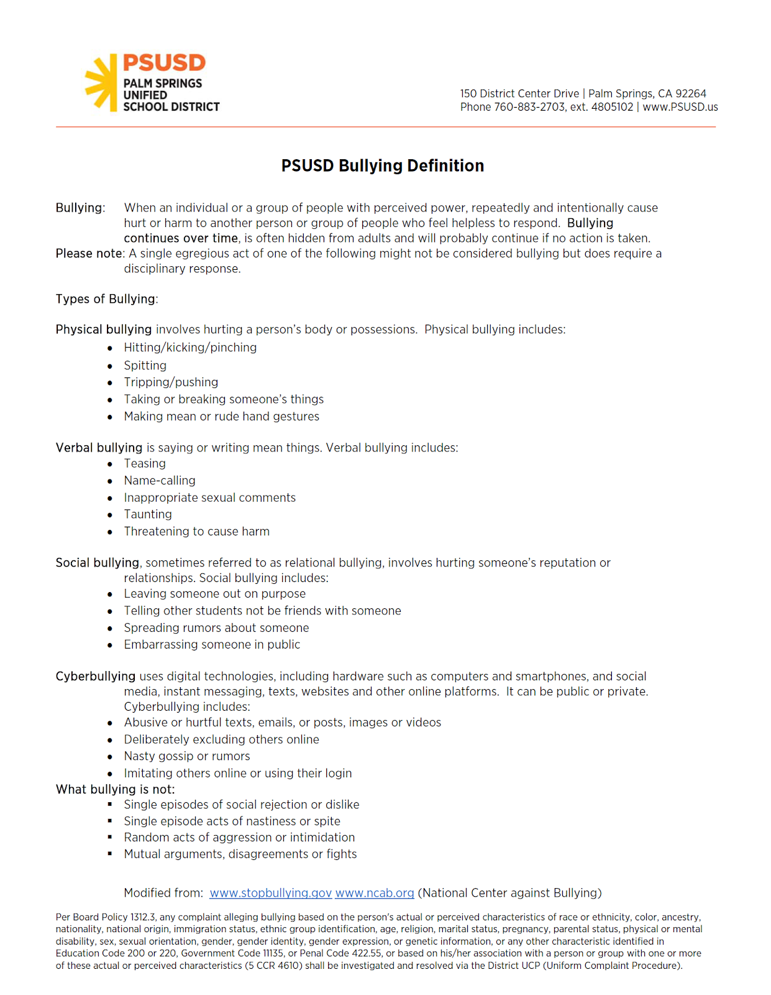
GENDER EQUALITY: We are proud that Katherine Finchy elementary contains a diverse population of students, staff, and families. It is important that our students learn from one another as well as grow into adults of good character. We practice Character Counts! throughout the school year and work hard to bring programs of diversity, tolerance, and motivation to our students. If you or someone you know would be a great role model or motivational speaker for our kids, please see our principal, Dr. Saunders to plan a program. All school programs and activities shall be free from discrimination, including harassment, with respect to actual or perceived ethnic group identification, race, ancestry, national origin, religion, age, sex (gender—actual or perceived), sexual orientation, physical or mental disability, or parental status. Equal opportunity for all individuals in district programs and activities, all individuals treated equally no matter what category they identify with. Annual parent notification shall inform parents/guardians of their children's right to a free public education regardless of immigration status or religious beliefs, including information on educational rights issued by the California Attorney General. Alternatively, such information may be provided through any other cost-effective means determined by the Superintendent or designee. Access for Individuals with Disabilities (BP 0410).

SAFE SCHOOL STATEMENT: The Palm Springs Unified School District and Katherine Finchy Elementary are committed to a safe environment for all students and staff and will not tolerate any weapons, implements, or substances used as weapons, unauthorized drugs, violence, gang activity, or vandalism on any campus. “Weapons” shall include but are not limited to guns, “look-a-likes”, any knife, martial arts tools, razor blades, or mace. Any student who is found to have initiated an attack, assault, use of force or threat to a school employee will be suspended / expelled. The appropriate law enforcement agency will be contacted and a report will be filed. There is a “zero-tolerance” approach towards this type of behavior. Such behavior is totally unacceptable and will be dealt with decisively.

Our staff is extremely well trained and their primary concern is the safety of each child. Please contact Mr. Matthew Hammond, Principal, with any concern or special needs at 416-8190.

- All visitors must register at the office and receive a visitor badge by using our Raptor screening system.
- If for some reason you must pick your child up after 4:00pm, please call the office before it closes and speak to any person who works in the office.
- The gates are all locked during school hours. We have a lock down safety code for all classes so that with one call, every room is locked.
- All classrooms have telephones to contact the office for any reason.
- Continual observations and surveillance are made on campus regularly for strangers.
- Campus wide cameras are in place to promote optimal surveillance of school grounds.
- Our emergency cards are updated regularly and precautions taken for those who have specific needs. Please be sure your child’s records are current at all times.
- We regularly practice emergency procedures (fire and earthquake drills).
- We maintain an emergency container with supplies in case of a fire or earthquake.
- Our staff all wears bright yellow vests for easy identification while on supervision duty.
- Our custodian and our yard supervisors have handheld communication radios and can call the office at any time. In addition, multiple classrooms are equipped as well.
- The district maintains security personnel and an emergency phone line to all schools.

Again, please bring any concerns to our attention. We are very proud of our children, school, staff, and campus.

Uniform Complaint Procedures. A complainant who is not satisfied with the district's decision may appeal the decision to the California Department of Education (CDE). If the district or CDE finds merit in an appeal, the district shall provide a remedy to the affected student. (Education Code 222, 46015; 5
CCR 4600- 4670)
(BP 5146)

Palm Springs Unified School District

Nondiscrimination Statement

No person shall on the basis of sex, race, national origin, or non-limiting handicapped conditions be excluded from participation in or be denied the benefits of or be subjected to discrimination under any educational program offered by Palm Springs Unified School District. Programs offered by the District include a variety of vocational education programs, including those in the areas of Business, Consumer Home Economics, and Technical/Industrial. There are no special admission requirements for these programs except to progress sequentially from level to level. Lack of English language skill shall not be a barrier to admission and participation in vocational education programs.
The District’s Coordinators are:

TITLE IX - Nondiscrimination on the Basis of Sex
Mark Arnold, Director
State and Federal Programs
150 District Center Drive
Palm Springs, California 92262
Phone: (760) 883-2700

SECTION 504 (Nondiscrimination on the Basis of Handicap)
Dr. Anne Kalisek, Executive Director
150 District Center Drive
Palm Springs, California 92262
Phone: (760) 883-2700

Parent Student Handbook 2020-2021

Parents,

Please help your child think of a goal that they would like to reach by the first of November. It can be a behavioral goal or an academic goal. Then list 3 things that your child or you can do to help his/her reach their goal. The teachers will review this at Back to School Night, so if you are having difficulty, please wait until then to set the goal.

Student Goal
My goal for this trimester is: _______________________________________________________________

_______________________________________________________________________________________

Three things I will do to help achieve my goal:

- _________________________________________________________________________________

- _________________________________________________________________________________

3. _________________________________________________________________________________

My child, ________________________________, and I have read and reviewed the Parent Student

Handbook and agree to this goal.

Student’s signature ___________________________________________________

Parent signature ______________________________________________________

Date _______________________

Teacher _______________________________________

